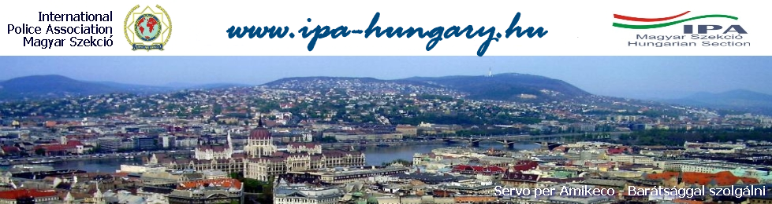
IPA HUNGARIAN SECTION – anniversary and friendshipdAys 2016
„5 DAYS, 25 YEARS, 25 PROGRAMS
we are waiting FOR you in hungary, in THE heart of europe!”
Budapest, SEPTEMBER 5th – 10th 2016
Dear IPA Friends,
come and celebrate with us, get known the wonders of Hungary! Recognise Hungary’s landscapes, our traditions, our natural resources and our gastronomy with the help of the
25 years old Hungarian Section.

Program
September 5th 2016
Arrival of the guests in the Hotel Benczúr (Budapest, VI., Benczúr Street 35. Web: www.hotelbenczur.hu) between 13 and 17 hours, registration, occupation of the accommodation.
18:30 Welcome-party, dinner in the restaurant of the hotel
September 6th 2016 „ Hungary: homeland of the plains” and “Back into the Turkish times”
Breakfast at the hotel
09:00 Travelling to Hortobágy
11:00-22:30 Hortobágy: The magnificent, endless wasteland is now the most prominent natural worder in Hungary, the most untouched corner of Europe, its flora and fauna are a Biosphere Reserve and it is a World Heritage Site from 1999.
Visit rascals' world -getting acquainted with the Hungarian lowland, wranglers’ life , dishes of the lowland , wines of the wine region, Hajós.

Travelling to Eger.
Turkish world in Hungary- Eger Castle. The Castle of Eger is one of the earliest Hungarian fortifications and the cathedral of the Episcopate founded by Saint Stephen was surrounded by walls as early as the 11th century. The castle achieved the pinnacle of its military glory in the course of the Turkish siege in 1552, the handful of poorly equipped, yet fanatically devoted defenders led by Captain István Dobó resisted the overwhelming superiority of the attacking forces for 38 days. At the end, due to its severe losses, the Turkish host disgracefully retreated under the cover of night from under the demolished, yet unassailable walls of the fort.
The world of the Hungarian border fortresses in the Middle Ages, Eger - visit to the Castle Eger, the world famous Hungarian wine region: Eger, wine tasting, tavern dinner, highland foods from the mountains Mátra, wines of the wine region, Eger.

September 7th 2016 Balaton, “the "Hungarian Sea", and the world-famous Herend Porcelain Manufactory”
Breakfast at the hotel
09:00 Travelling to Herend
11:00-22:00 Herend - the world-famous Hungarian china manufactory.
Porcelain: Making ceramics is a thousand-year-old tradition in Hungary, which boasts a number of active pottery centres. Kaolin is the raw material used for porcelain, a white rock. Porcelain manufacturing requests great skill. However, it is extremely elastic, producing a paper-thin, nearly translucent material. Due to the high temperatures used, it is commonly decorated with lead glaze.
Presentation of the neighbourhood of the Balaton- Lake Balaton – captures a landlocked country’s nostalgia for a stretch of open water. It is also known as the Hungarian sea, even though you can easily swim from one shore to the other.
Its surface area of nearly 600 square kilometres is the largest lake in Central Europe.
Tihany, talk to the "Tihany-echo", Balatonfüred, short boat trip on the lake Balaton, dishes from Bakony mountains, wines of the wine region Balaton. Dinner in Budapest.

September 8th 2016 “Budapest, the jewel of the river Danube”
Breakfast at the hotel
09:00 – 22.30 Getting acquainted with Budapest, capital of Hungary- sightseeing tours by bus and on foot, the building of the Hungarian Parliament, Zwack Unicum Museum, and the Zwack factory, Buda Castle, a world heritage site, the lights of Budapest from a boat, dinner on the boat, traditional Hungarian dishes, Hungarian wines from the wine region Villány.

September 9th 2016 „ 25 years anniversary of IPA Hungarian Section”
Breakfast at the hotel
09:00 Travelling to the spot of the official celebration (National Police Headquarters)
Participation at the ceremony of the Hungarian Section. (uniform or IPA dress)
Lunch- traditional dishes described in the Hungarian literature, wines from Buda mountains.
From 15:30: Free program in the capital
18:00: Travelling to the spot of Farewell evening
19:00 Saying goodbye to the Hungarian Section, saying goodbye to Budapest - folklore program, the lights of Budapest from the Buda mountains, traditional Hungarian dishes, modern Hungarian wines.

September 10th 2016 After breakfast departure of the guests.
Our program is subject to changes!
Each applicant has to fill out an Application Form.
FULL COSTS OF THE PROGRAMS: 600,- €/Person/in a double room. 660,- €/Person/ in a single room.
The program cost includes: participation at each program, meals, drink (limited drinks), transfer to the locations of the programs and gift.
Costs do not include transfer and parking (about 10,- €/day). The transfer is just on the 5th September (arrival’s day) and the 10th of September (departure day). Price: „Liszt Ferenc Airport: from/to 20,-€/person/2ways, 10,-€/person/1way, from or back, Railway station „Keleti” from/to 10,-€/person/2ways, 5,-€/person/1way, from or back.
APPLICATION AND PAYMENT DETAILS:
Application deadline: 1th June 2016. Advance payment – 200 EURO/person at the application. Remaining part has to be paid until 31th July 2016.
Cancellation with full refund till 31th July 2016, after that date we cannot refund advance payments.
APPLICATION AND INFORMATION: vicepresident3@ipa-hungary.hu or mmarcsi1@chello.hu (Maria Mészáros English, German, Italian)
Please transfer participation costs on following bank account

Name of account owner: IPA MAGYAR SZEKCIÓ
Account number: 11705008-20415891-00000000
IBAN: HU39 11705008-20415891-00000000
BIC (SWIFT): OTPVHUHB
Please make following remark to your transfer: „IPA Hungarian Section 25 years” plus the name of remitter.
We were glad, if we could great you personally in the name of IPA Hungarian Section here in the heart of Europe, in Hungary. Do not miss this opportunity, visit us and celebrate with us!
Presidium of IPA Hungarian Section
